CHAPTER 2

LITERATURE REVIEW

This chapter will discuss the literature of Centralized Web-Based System for Stress Induction Methods. This chapter give information about the project reputable publications including journals, articles, and other materials.
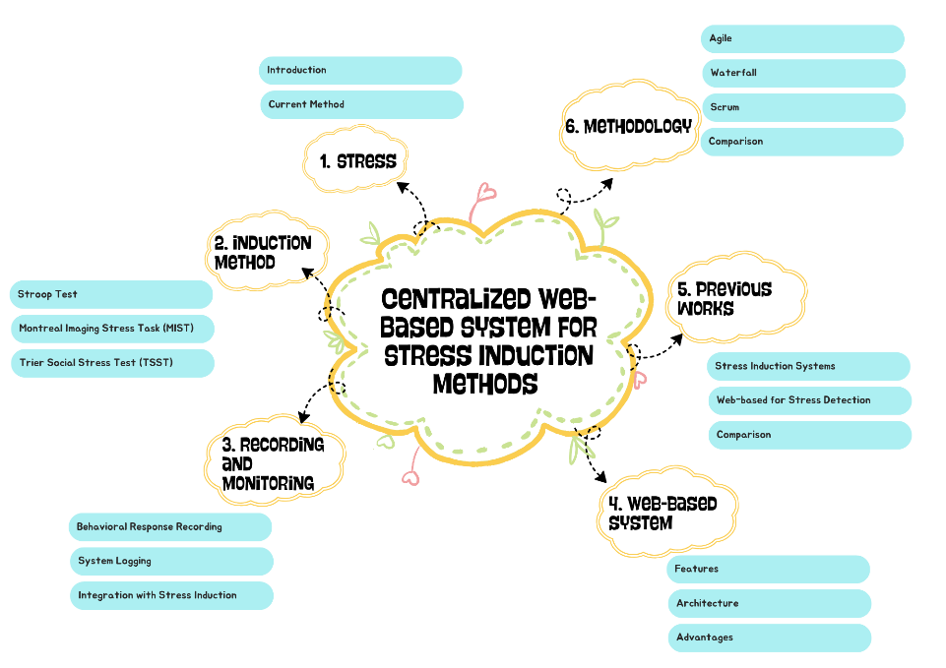
Figure 2.1 Overview of Literature Review
Figure 2.1 describes the overview of the topics that are studied in this chapter. This chapter are consisting of four different subtopic which are Induction Methods, Web-Based System, Previous Works, and Methodology for the system’s development.
2.1 Stress
A type of psychological tension or strain that is challenging to control or tolerate is known as psychological stress. Stress affects a range of physiological and psychological aspects of behaviour, emotions, and mental processes (Allen et al., 2017). The Hypothalamic-Pituitary-Adrenal (HPA) Axis is best known for its role for body’s natural reaction to stress (University of New Hampshire, Psychological and Counseling Services [PACS], nd).
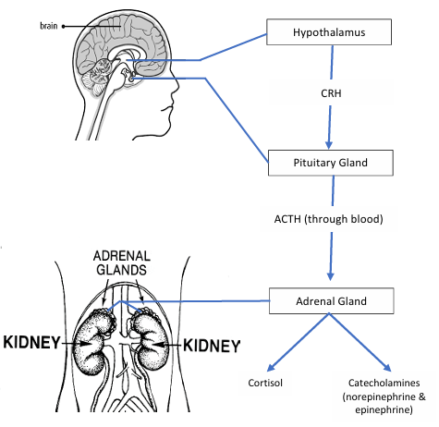
Figure 2.2 The Biological Mechanism of Stress Response through the HPA Axis (PACS, n.d.).
Figure 2.2 show the description of what occurs in one’s brain and body when experiencing something stressful:
- The hypothalamus releases a hormone called corticotropin-releasing hormone (CRH).
- CRH signals the pituitary gland to create a hormone called adrenocorticotropic hormone (ACTH) into the bloodstream.
- ACTH travels down to adrenal glands where it releases different hormones from different parts of the adrenal glands. It causes the secretion of a class of steroid hormones called glucocorticoids from the cortex and one of this is cortisol which become one of main role in the stress response.
The release of cortisol and catecholamines will energize the fight-or-flight response.
In Malaysia, stress is increasing concern among Malaysian youth, overall score for youth aged 15 to 30 years is 71.91 according to Malaysian Youth Mental Health Index 2023 (IYRES, UNICEF, 2024) which this score indicates a moderate risk of youth facing mental health issues. If these stresses are left untreated, it can lead to more serious mental health.
Stress can affect both physical and psychological health. Even though stress can help some people to work more productive, high stress levels can cause sleep problems, irritability, and poor concentration (Lazarus et al., 1984). Without treating it, chronic stress can lead to health issues such as heart disease, diabetes, and week immunity (Schneiderman et al., 2005). According to McEwen and Akil (2020), brain is the central component in the body and responds to stress which include three interconnected limbic brain regions:
- Hippocampus: This part is the key in learning, memory, and terminating the stress response. Long term stress can lead to its shrinkage which also leads to conditions like major depression and Post-Traumatic Stress Disorder (PTSD).
- Amygdala: This area is response in emotional and affective responses.
- Prefrontal Cortex (PFC): Found to induce adaptive structural plasticity within brain area that are linked.
Stress is important to be addressed in any state and to be managed. According to Oliveira et al. (2022), managing stress might help in improve emotional stability where it can also improve the performance and productivity. Workplace policies that reduce and assist employees in managing work-related stress can boost productivity and encouraging mental wellness which it will lowers presenteeism and absenteeism. Addressing stress in early stage help to prevent long-term physical and psychological damage such as suppressed synaptic functions, reduced neuroplasticity, and possible neural damage.
2.1.1 Current Methods to Overcome Stress
Currently, there is various clinical and non-clinical way have been developed to help manage and reduce stress (American Psychological Association [APA], 2025). These methods made to stabilize emotional, cognitive, and physiological responses caused by stress.
One of the methods is the Cognitive Behavioural Therapy (CBT), where it helps individuals identify negative thought. CBT has been proven effective for anxiety, depression, chronic stress (Hoffman et al., 2012). Other than that, Mindfulness-Based Stress Reduction (MBSR) is one of the methods that focus in psychological and behavioural approaches where it focuses the individual on being aware and accepting the current moment which reduces cortisol levels and improves emotional regulation (Kabat-Zinn, 2013).
In term of pharmacological interventions, the used of antidepressant and anxiolytics help to reduce the severe or chronic stress cases which can lead to anxiety or mood disorders (National Institute of Mental Health, 2022). However, keep depending on this drug can cause a severe withdrawal syndrome that bring back the anxiety and insomnia, agitation, and even worse, seizures (Addiction Center, 2025). Clinically, standard tests like the Trier Social Stress Test or the Perceived Stress Scale help measure how someone reacts to pressure, both physically and mentally, in set-up situations (Kirschbaum et al., 1993; Cohen et al., 1983).
2.2 Stress Induction Methods
Stress Induction is important part in psychological research where the goal is to reliably and ethically elicit a measurable acute stress response in participants under controlled conditions (Dickerson et al., 2004). Centralizing and standardizing this procedure may help for carrying out thorough scientific research.
Stress induction tasks are usually conducted in lab or computer. The process needs to be presenting time pressure or cognitive overload to the stressor to triggers their stress. Researchers need to monitor their response and ensure ethical safety toward participants (Kirschbaum et al., 1993). The mostly used in stress induction methods are, the Stroop Test, Montreal Imaging Stress Task (MIST), and Trier Social Stress Test (TSST) which are mostly recognized by psychological and physiological research (Kirschbaum et al., 1993; Dedovic et al., 2005; Muller et al., 2022).
2.2.1 Stroop Test
The Stroop Colour and Word Test is one of the most widely used tools in psychology and neuroscience research. Often applied to assess focus, mental regulation, or reactions under strain (Stroop, 1935). The test uses a cognitive conflict known as Stroop interference, which the test will mismatch word and colour of the word. This inconsistency increases the cognitive workload while emotional tension builds at low levels which make the Stroop Test suitable to use to trigger controlled pressure situations (MacLeod, 1991; Scarpina et al., 2017).
The Stroop Test, also known as the colour-word naming test, was first described by Stroop and has been widely used in psychological research (Jensen, 1965). Stroop Test used to assess a range of process and characteristics in cognitive and personality domain (Jensen, 1965). Stroop Test can evaluate cognitive reflect, processing speed, and selective attention by asking participant to choose the colour of ink but different in word. For example, participant must choose "red" not "green" when the word "GREEN" is displayed in red colour.

Figure 2.3 Word “GREEN” displayed in red ink
Recent studies have compared the Emotional Stroop Test (EST) in offline laboratory test with online test where they found no significant differences between both methods showed how the Stroop Test are well suited to use in web-based system (Imbir et al., 2025)
In experimental setup, Stroop Test require participant to sit in a quiet and controlled environment to minimize external distractions. The screen sits straight at eye level and participant will take their place about 50 to 70 cm away from the screen. Before start, they will receive brief instruction to helps them understand what to do. (Karthikeyan et al., 2011).
During the test, each part will show around 1 to 2 seconds depend on how difficult the task is. Participant must choose the colour using mouse click. The system will record reaction time, accuracy rate, number of errors, and participant behaviour toward the test (Scarpina & Tagini, 2017). Correct responses are defined as identifying the correct colour of word that have been presented accurately, and the incorrect responses are when the participants choose the wrong word instead of its colour which giving the interference effects in selective attention (MacLeod, 1991).
In this study, Stroop Test will have around 30 questions which include the colour and the word of colour with a duration of 3 minutes to give task sensitivity and participant fatigue (Salo et al., 2020). This duration is enough to induce cognitive load to get a consistent measure towards all participants (Karthikeyan et al., 2011).

2.2.2 Montreal Imaging Stress Task (MIST)
The Montreal Imaging Stress Task (MIST) is a computerized mental arithmetic test designed to trigger psychological stress consistently in lab settings. Originally made for functional magnetic resonance imaging (fMRI) studies, it allows tight control over cognitive load and social evaluative threat (Dedovic et al., 2005). After being introduced, this tool becomes widely use across neuroimaging, physiology, and cognitive research because it activates the HPA axis while boosting cortisol levels (Pruessner et al., 2008; Reinhardt et al., 2012).
The MIST aims to create performance pressure, time pressure, and social evaluation. Each raising mental stress while enabling researchers to track actions and brain activity instantly.
The three primary operating (Nirabi et al., 2025; Malik & Amin, 2017; Dong et al., 2024):
- Rest (Baseline) Condition: This condition is shown to participant with a static screen with no tasks, allowing to get the baseline mental and physical condition.
- Control Condition: Involves participants to solve arithmetic problems in comfortable and easy difficulty, design to match the participants capacity. Thus, the cognitive effort is isolated without causing the stress.
- Experimental Condition: Manipulates the arithmetic challenge by adjusting the difficulty and time limitations to challenge the participants maximum capacity.
The MIST giving the real-time performance feedback shown to boost stress and social assessment. This test usually includes a countdown timer and score to give more pressure towards the participant for example “Too Slow! or Incorrect” which it will heightens the social evaluative pressure and sense of failure (Dedovic et al., 2005).
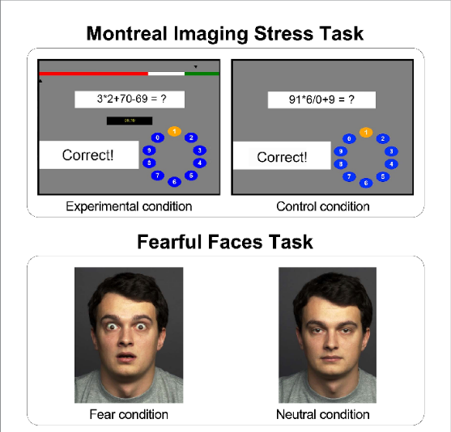
Figure 2.4 Example of Montreal Imaging Stress Task (MIST) showing arithmetic challenge with real-time feedback (Sudimac & Kuhn, 2022)
The arithmetic question used in MIST designed to vary in difficulty and complexity depend on different stages based on the phase. The question is vary, some stage uses simple equations, others mix several operations like multiplication, and division together. Researchers found this setup pushes mental effort consistently (Dedovic et al., 2005; Pruessner et al; 2008).
In the Control Condition, questions are simple and easy to solve within given time. These questions are designed to fit participant capability without triggering their stress. Example of Control Condition questions:
- 12 + 4
- 3 + 5
These simple arithmetic questions ensure that the participant respond confidently without triggering their stress levels (Malik & Amin, 2017).
In the Experimental Condition, it uses tougher questions that need several thinking steps and quick answer under strict time. The setup cuts down response time or increasing the challenge level to create more pressure (Dedovic et al., 2005). Examples of Experimental Condition questions:
- (45 / 5) x 4 – 7
- (128 / 4) + (36 / 3) – 10
- (1201 / 12) + (210 / 5) / 3
These questions require higher level of thinking which contribute to cognitive overload when time pressure and feedback are present. Research shows that forcing participants finish quickly under unrealistic time limits will increase their stress level especially when it combines with feedback message like “Too Slow!” or “Incorrect” after each try (Reinhardt et al., 2012; Sudimac & Kuhn, 2022).
The arithmetic question format is used on purpose because it tests (Dedovic et al., 2005; Nirabi et al., 2025):
- Requires continuous cognitive effort
- Works for almost every education levels
- Clear timing adjustment along with challenge difficulty
- Produces measurable reaction times and the frequency of errors
- Easily integrate with fMRI, EEG, also handles web-based test
These characteristics make arithmetic challenges work better than word or memory-based tasks to trigger social evaluative pressure during lab or web tests (Dedovic et al., 2005; Nirabi et al., 2025).
In typical MIST setup, the setup takes place in controlled, quiet, and distraction-free environments to shifts in mental or bodily reactions directly to the activity rather than external disturbances (Pruessner et al., 2008). The participants sit comfortably before a monitor positioned with their eyes level, usually 50 to 70 cm away from the screen. Once started, the screen will show how arithmetic questions work, ways to respond, along with an outline of what happens every phase. Researchers may provide a brief practice to ensure participants understand the flow (Dedovic et al., 2005).
The task moves across three standard MIST phases, Rest (Baseline), Control, and Experimental. Each lasting from 3 to 5 minutes. During the Rest phase, the screen will show a static non-task screen, allowing to record baseline measurements like heartbeat, breathing, and mental calmness. In Control phase, basic problems show up slowly, without time pressure or scoring, help researchers to observe cognitive performance without any stress effects. Participants can work through the question in their own pace which keeps stress level low throughout this phase (Reinhardt et al., 2012).
The Experimental Phase brings in key parts of MIST which to raise stress levels. As the task goes on, arithmetic questions get harder while time limits shorter which sometimes make it impossible to finish it. Adaptive algorithms may adjust problem difficulty to maintain a target error rate of around 40 to 50%, keeping stress steady between people (Pruessner et al., 2008). Feedback appears on screen, such as “Incorrect!” or “Try Again!” appear after mistakes. Earlier studies show these kinds of social evaluative component are triggering stress and HPA-axis activation (Dedovic et al., 2005; Sudimac & Kuhn, 2022).
During the session, the system gathers behaviour information along with psychological data, including:
- reaction time,
- accuracy and error rates
- number of attempts per question
- task completion rate
- facial expression and behavioural
In some setups, additional environmental controls like low light or chair positions are use and also restricting how much participants can move. Research shows keeping the same boosts accuracy while cutting down shifts in stress reactions (Reinhardt et al., 2012; Kirshbaum et al., 2020).
The performance of the participant in the MIST is scored according to the number of correct and incorrect responses, and the time of response in the Control and Experimental conditions, with each arithmetic question requiring a single numerical answer within a predefined time limit.
A response is considered to be correct when a participant submits the correct numerical answer before the expiration of the time limit. A response is considered to be incorrect when the participant submits an answer that is incorrect or fails to respond within the given time limit. Incorrect answers and time-out events are considered as errors since they show task difficulty and cognitive overload.
Indicators for these categories are specified, and performance scoring is computed using indicators such as the following (Pruessner et al., 2008):
- Total Correct Responses (C): No. of correct answers to the math problems within the timely limits
- Total wrong responses: The number of wrong responses or the items that were not responded because of the expiration of the test time.
- Total Attempts (T): Total number of questions presented, where:

 | T = C + I | ... (1)

The accuracy rate is calculated as:

 | Accuracy Rate = ( $\frac{C}{T}$ ) x 100 | ... (2)

The error rate is calculated as:
 | Error Rate = ( $\frac{I}{T}$ ) x 100 | ... (3)
Besides response accuracy, the current system also measures reaction time which is defined as an interval between the appearance of an arithmetic task and the participant submitting their response. The average reaction time across trials is conventionally viewed as reflecting the number of operations or steps involved in information processing and the relative speed or efficiency with which they are executed under stress (Reinhardt et al., 2012; Kirschbaum et al., 1993).
The MIST adapts its difficulty during the Experimental Condition to induce consistent amounts of stress across individuals. Task difficulty and time constraints are adjusted dynamically based on ongoing performance, maintaining an error rate of approximately 40–50%, a range shown to reliably induce psychological stress and activate the HPA axis (Pruessner et al., 2008; Dedovic et al., 2005).
These scoring mechanisms provide standardized quantifiable measures of performance degradation under stress and support automated implementation in laboratory-based and Web-based stress induction systems.
Overall, the MIST setups designed to provide standardized, repeatable way to trigger stress under close control. Cognitive load, social evaluative threat, and time pressure can be adjusted step by step to induce stress response. This makes the MIST an optimal tool not just in brain scans, yet also on online system meant to bring consistent stress induction remotely.
2.2.3 Trier Social Stress Test (TSST)
The Trier Social Stress Test (TSST) is an ecologically sound technique that uses social assessment and uncertainty to create acute psychological stress. Considered as “gold standard” for giving moderate stress in laboratory setting (Kirschbaum et al., 1993). TSST is mostly dependent on stress caused by public speaking and mental performance being observed (Allen et al., 2017). TSST was created to address the shortcomings of previous stress protocols, consistently activated the main psychological stress such as sympathetic-adrenal-medullary (SAM) axis and the HPA axis (Allen et al., 2017; Kirschbaum et al., 1993).
TSST usually has three organized parts meant to maximize social-evaluative threat and induce a sense of uncontrollability (Dickerson & Kemeny, 2004).
- Preparation Phase: Before starting, participants get instructions around ten minutes to deliver a speech in front of trained and unbiased listeners who will not reach much.
- Public Speaking Phase: Participants deliver the speech while the panel judge them silently. Panel will keep the blank face which ramps up the nerves of participants.
- Mental Arithmetic Phase: Participants perform a surprise arithmetic task right after talking, which boosts stress and mental effort (Kirschbaum et al., 1993).
Even though the TSST works well, doing it in traditional implementations needs a few trained people playing as judge and watcher. That setup takes up lots of effort, costly, also limits use in distant or broad settings (Norden et al., 2022).
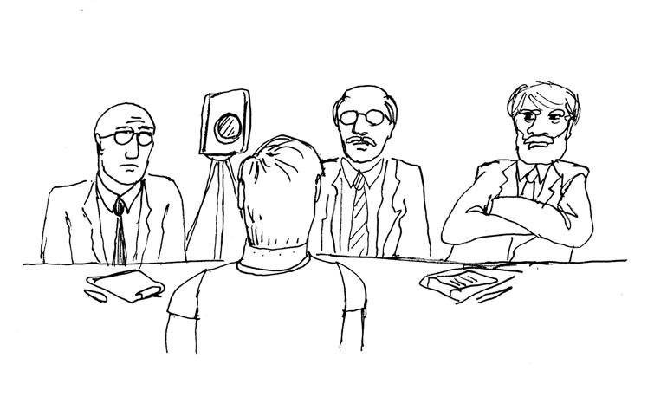
Figure 2.5 A drawing showing how the TSST is conducted (Coetzee, 2012).
One of the TSST phases that been focused on is TSST Arithmetic Task. The TSST Arithmetic Task requires a controlled setup to ensures that the conditions face by each participant in terms of cognitive load, time pressure, and social evaluative are consistently applied. Usually done in laboratory with evaluator or researcher on site. However, digital versions can be adapted with standardized procedures.
In original TSST protocol, the arithmetic task conducted when participants gave their speech. The environment should stay plain, quiet look, bright lighting to make participants feel seen, quiet, and the assessment group prepared with two or three trained staff that keep calm and neutral (Kirschbaum et al., 1993). A digital watch or clock on the wall sits within view, so the participant sees how much time is left, reinforcing the sense of urgency.
To maintain consistency with the original TSST, the arithmetic task should use this setup:
- Starting number: Starting with any number for example, 1022 or 2043 (Kirschbaum et al., 1997).
- Subtraction gap: 13 or 17, depending on how the research was set up.
- Restart rule: If wrong, start again at the beginning, this setup amps up stress and mental effort (Kirschbaum et al., 1997).
- Duration: Between 3 and 5 minutes (Allen et al., 2017).
The researcher gives instructions clearly, to ensure each participant know exactly what is expected.
The social pressure plays a big role in making TSST stressful. When it comes to the arithmetic phase:
- Researchers keep blank faces and stay quiet.
- Researchers might fix mistakes in a flat tone using phrases like: “Incorrect. Please restart.” or “Continue”.
- No words of approval, comfort, or emotional reactions are given (Dickerson, Kemeny, 2004).
- This method increases how much participant feel of being judged, making the participant think others are sizing up their skills.
With the usage of TSST into web-based platform, the arithmetic task can be delivered online while keeping the key stress inducing component.
Digital formats usually come with:
- A countdown timer visible on screen
- Input field to type the answer
- Instruction popped up before the task
- Instant alert when mistake is made such as: “Incorrect! Restart from 1022.”
- These prompts act like feedback and adding pressure (Norden et al., 2022).
In Trier Social Stress Test arithmetic task, performance is measured based on objective behavioural parameters such as correct responses, incorrect responses, time associated with responses, and continuity with tasks under social evaluative pressure. The arithmetic challenge in Trier Social Stress Test primarily involves subtracting serially with a time constraint under the evaluation of judges or simulation of evaluative conditions in digital versions (Kirschbaum et al., 1993; Dickerson & Kemeny, 2004).
a) Correct Response
Response is correct if participant able to subtract in sequence.
b) Incorrect Response
Response is incorrect if participant unable to subtract in sequence. They must begin from start with the first number as stated by the researchers. (Kirschbaum et al., 1993; Kirschbaum et al., 1997).
Performance scoring is based on the following metrics:
- Total Correct Responses (C): Number of correct subtraction steps completed sequentially without error
- Total Incorrect Responses (I): Number of incorrect subtraction steps, restarts, or prolonged response delays
- Total Attempts (T): Total number of subtraction steps attempted, where:

 | T = C + I | ... (1)
The accuracy rate is calculated as:
 | Accuracy Rate = ( $\frac{C}{T}$ ) x 100 | ... (2)
The error rate is calculated as:
 | Error Rate = ( $\frac{I}{T}$ ) x 100 | ... (3)
The arithmetic task in the TSST is usually between 3 to 5 minutes (Kirschbaum et al., 1993).
2.3 Recording and Monitoring
Recording and monitoring are one of the most important parts in studying the stress because it provides objective data on how people react towards stress test. There is a demand for these methods because of the use of the traditional way which is self-report-based stress test can be subjective bias (Korkmaz et al., 2025). According to Shirtcliff et al. (2024), demonstrating stress induction like MIST relies on precise behavioural measure with real-time feedback. These tasks need to have a coordinated system that align the timing of the participant during the test.
Most protocols are mostly limited to traditional laboratory settings that are manually observing, labour-intensive and cannot be scaled to larger place (Norden et al., 2022). Studies show that traditional method or manual method are suffers from issues such as human error, subjective observations, and poor scalability that could burdened by researchers (Vikoler et al., 2025). With digital tools become common, stress test can be done remotely and be use in web-based system which improve consistency and reduce manual effort (Wielgopolan et al., 2025).
However, current digital a scattered in every website with different interfaces and data-logging format especially for standardized stress induction methods (Vikoler et al., 2025). According to Al Sahili et al. (2025), explicitly states that most of digital technology that existed are “fragmented data silos” and “inconsistent annotations schemes” where applications concentrate on individual modalities rather than collaborating. The fragmented platform could easily result in some incomplete or disorganized data, and because of these “fragmented data silos,” it could be hard to create trustworthy models (Al Sahili et al., 2025).
2.3.1 Behavioural Response Recording
While measuring their responses, it is important to see how people behave on stressful tasks. Speed, accuracy, errors made, or consistent responses are needed to show how much the thought process works when put under stress. Delayed or slow responses may suggest that a person's brain is overloaded the moment stress sets in (Karthikeyan et al., 2011). Where the question of hitting targets or avoiding errors arises, any failure to do so may become indicative of a diversion of attention under stress, as in the case of colour word tests or fast mental arithmetic, where stress increases errors (Dedovic et al., 2005). Keeping such measures helps researchers identify actual changes in brain activity while assessing the degree of disruption caused by stress in the task performance. Observational hints about human behaviour provide further insight into test scores, where overt signs of strain on the performance of various tasks can be detected with the help of sounds or visual features. These are generally recorded through video or audio recordings for researchers to measure changes in facial expressions, or the endpoints of eye gaze, posture, or overall motion patterns (Giannakakis et al., 2017).
Actions such as doing many movements from foot to foot, holding back answers for a long period, or showing irritation may reveal mental pressure increasing (Zhou, et al., 2018). Audio recording can reveal the participant stress from the voice which sometimes the participant will stutter and pause when speaking (Norden et al., 2022).
Synchronization of body-based signals enhances the ability of researchers to track behaviour when people are under stress. Instead of looking at actions, researchers record things like slowed reactions or obvious signs of strain with physical changes. The increased heartbeat, sweat responses, or changes in cortisol (Kirschbaum et al., 1993). Since these readings come out synchronized, it is easy to establish if a stumble in focus happens right at the point when the body shows peak stress. This linking of outward actions with inner states of the body confirms that what one gets is linked to stress and not random variation. Combining both types of data strengthens conclusions about how pressure affects cognition and mood. It can also make results easier to compare across different persons, even when situations are varied slightly.
Recording what individuals do provides good evidence about stress, and research findings become more reliable. Rather than having computer estimates of how someone might feel, it also records actual behaviour like speed or errors, which reduces the number of personal perspectives (Norden et al., 2022). Because computers record all these points every time, data points remain constant regardless of who it done on or when it happens. That is also because computers can avoid human errors from over-monitoring. In addition to that, data points from these processes correlate perfectly with heart rate trackers or video recordings, providing scientists with complete data points without clashing pieces of information. Because of accessible internet assistance, storing, examining, or analysing behaviour data on a larger scale becomes possible like they are intended to in scientific labs or browsers today (Scarpina & Tagini, 2017; Wielgopolan et al., 2025).
2.3.2 System Logging
System logging is an activity that automatically records all the activities performed by the users on the stress testing environment. Therefore, whenever participant react, doing tasks, or giving feedback on the system, all this is automatically logged along with exact timings. Since this activity is carried out without the help of humans, all the actions taken by people are also reflected accurately as they occurred, leading to an effective record of how they have conducted themselves during the testing process (Norden et al., 2022). Because all activities are not manually written down, errors decline, and all participants have an equal chance of being recorded.
System logs store information all information such as the participant’s name, result, and test timing. It is important for researchers to note that system logs keep a clean and organized record of events that occurred during experiments. Therefore, the data logging will prevent the possibility of data error. By being able to refer to log statements to determine if actions went as planned using system logs also allows for recognizing possible dysfunctions or strange performances during the testing process (Scarpina et al., 2017). It is easier for others to replicate research results because research specifics can be seen clearly. In addition to that, standardized techniques are possible in separate labs.
2.3.3 Integration with Stress Induction
Stress testing and tracking devices must operate effectively together for a setup to be considered good. Activities such as a colour change, arithmetic problems, relates well to real-life behaviour and recordings of the body’s response to different task. If this is the case, then it is easier to identify a direct response to the stimulus administered (Dedovic et al., 2005). These setups allow the stress procedure to alter instantly according to the performance of the individual taking the test (Dedovic et al., 2005). In MIST, the test could alter in the middle of the test or the "Too Slow!" message would pop up, helping maintain a consistent stress level (Dedovic et al., 2005). Because of this, the levels of stress faced by each individual are consistent and play a critical role in the induction of physiological responses (Dedovic et al., 2005). A combination of different kinds of information sources, including behaviour files, videos, or even bodily signals, is easier to work with when integrated into a single system. Not only does this facilitate the work of scientists, as they do not need different equipment for individual tests, but different signs of stress can now be studied using a single setup, as opposed to individual equipment (Norden et al., 2022). Having information in a single system prevents the loss of information through the creation of folders, as everything is organized in a neat and efficient way, making the process of analysing easier (Norden et al., 2022).
The use of monitoring software in conjunction with activities that cause stress can make approaches more homogeneous in comparison to previous trials. Additionally, machines ensure similar configurations, timings, and reactions to each individual without variabilities introduced in manual processes (Scarpina et al., 2017). This is particularly essential in this discipline, as valid results require similar settings when repeating tasks.
Currently, the methods that the recording process has been relying on are those that use the manual method as well as external devices. Many of the stress methods that have been used are more often relying on the use of the manual method, which includes looking at the participants directly and note down all the progresses by hand, as well as the use of external devices like the stopwatch or the external camera (Norder et al., 2022). This particular method has been requiring the researcher to continuously monitor the participant in order to get the appropriate and consistent records. Many of the recording that record the participants’ reaction may be difficult for the test made by the participants to be synchronized. This has been requiring the researcher to manually link the test made by the participants to the recorded reaction, which may pose the risk of the reaction time mismatch (Al Sahili et al., 2025).
Because of these limitations, a web-based integrated system is needed where it can record participants reaction, test answers, and timestamps which can reduces human error and removes fragmentation by using in one centralized platform (Wielgopolan et al., 2025).
2.4 Web-Based System
Web-based platforms are more efficient, which can be implemented on a wide scale remotely, hence gradually replacing the conventional method for the study of stress induction (Richer, n.d.). Manual method of the stress test, according to Reiser et al. (2025), involves the use of various equipment, which can take time and may entail mistakes. In this case, the issue can be solved using the web-based method for the subjects. This means that the subject can do the stress test using the web-based system without necessarily visiting different websites, which might pose variability in the level of stress (Vikoler et al., 2025).
2.4.1 Features of Web-Based System
The web-based system is developed on a web browser platform that provides one-point access, management of user interactions, and systematic data management. A web-based system should balance security with usability and administrative convenience, especially in the online workplaces of today.
User authority and authentication are integral parts of a web application. The processes adopted for establishing authority through methods such as login credentials authenticate a person's identity. However, authorities also restrict how people use web applications about the role that each play. As Pressman (2010) asserts, role-based access control ensures that a person can only perform a certain task at the levels allowed by their authority.
a) User Profile Management
This makes it possible for the system to store user data in an organized manner. Each user has been given a distinct profile, which carries their account details. This helps in traceability, customization, and standard system usage (Sotnik, 2023).
With the centralized content and tasks, this implies that one can access all the functionality provided by the system using the central hub. This occurs with a higher level of centralized processing that avoids redundancy and achieves consistency throughout the system through the standardized process flow (Pressman, Maxim, 2020).
b) Automation
The automation and processing of the data will make sure the system records all inputs received from the user automatically. The automation of the system will remove any form of human interaction and will make the system highly reliable and accurate for all users (Sommerville, 2016).
c) Tracking
System logging and tracking record important actions that happen in a system, for example, actions carried out by a user, submissions, and transition actions. When actions that happen in a system are logged, they can be dated, which assists in tracing, debugging, and system performance analysis (Behl & Behl, 2017).
d) Database
Database Management and Data Storage acts as an organized repository for storing user records and system data. Its relevance lies in assisting in data persistence, integrity, and secure accessibility and processing of data for analysis (Elmasri & Navathe, 2016).

e) Dashboard
Administrative dashboards as well as control of the system work as a common interface that gives authorized users access to handle the settings of the system, as well as access data stored within the system, in addition to monitoring the usage of the system. Dashboards are helpful in boosting transparency as well as control within a system by combining control of the system in one interface as noted by Few (2013).
f) Accessibility
Browser access makes it possible for people to access the system using browsers without having to install software. This is due to the compatibility that the tool provides, as well as the ease of system maintenance (Nielsen, 2012).
2.4.2 Architecture of Web-Based System
The architecture of a web-based stress induction system is build using a three-tier structure, which separates the client, application, and database. This design ensures stability, scalability, and consistent task delivery across different devices and environments.
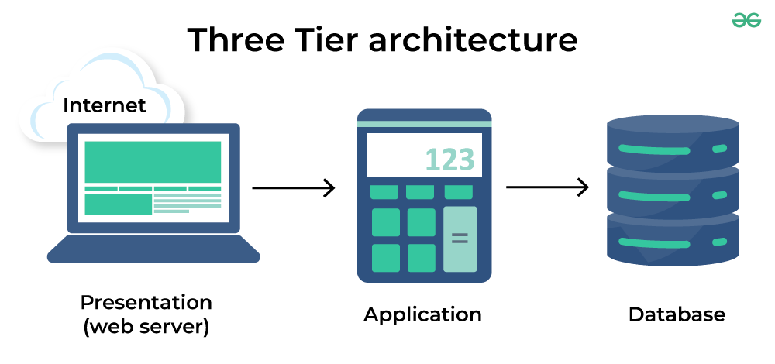
Figure 2.6 Three Tier Architecture in Distributed Server (geeks for geeks, 2025)
The first layer, known as the client layer, handles all user interactions through the web browser. Participants view test instructions, perform tasks such as the Stroop Test or MIST, and receive automated cues like “Incorrect!” or countdown timers [general on presentation layer]. Because this layer operates fully online, it supports device independence, allowing tests to run without installing additional programs (Scarpina et al., 2017).
The second layer is the application layer, which manages the main logic of the stress induction tasks. It is controlling task flow, adjusting difficulty levels, generating real-time feedback, and synchronizing behavioural responses including recording. For example, in MIST, the server will determine how easy or hard the test can be based on how the participant answer first three questions (Dedovic et al., 2005). The server layer also ensures that each participant will getting the same method of test without any human bias.
The third layer, the database layer, stores recording, and participant answer data. Using the databases will help researcher to store all participants answered question and recorded reaction. It also protects data from loss or mismatched with other data to avoid any unresponsible change toward the participants data (Norden et al., 2022).
2.4.3 Advantages of Web-Based System
Web-based systems have numerous benefits that make them suitable for developing applications that are centralized, scalable, and well-managed. The benefits of web-based systems stem from their use of web browsers for access, a centralized system architecture, as well as automated system operation processes (Sommerville, 2016; Pressman & Maxim, 2020). The good thing about web-based system is it can be accessed using browsers and there is no need to install any software or application (Nielsen, 2012). Centralized data management is another advantage where all data stores are in one place which avoid the risk of loss, duplication and misused by other organization (Elmasri & Navathe, 2016; Norden et al., 2022).
Finally, integration on the same platform increases the efficiency of the system and user experience. The fact that many functions are handled in one internet-based system means that the user does not have to navigate from one system to another. Such a system is able to offer more efficiency in operation (Pressman & Maxim, 2020).
In sum, these benefits prove the mechanism of web-based systems is a very effective foundation for centralized access, automated processing, and system management.
2.5 Previous Works
Research on stress induction methods has grown rapidly because of most researchers in stress study are shifting from traditional lab method to digital (Norden et al., 2022; Reiser et al., 2025). The popular stress induction methods that have be used by many researchers in traditional lab settings are TSST, MIST, Stroop Test where most of them has a good method to increase the stress level toward participants responses across cognitive, emotional, psychological (Kirschbaum et al., 1993; Kudielka et al., 2007; Dickerson & Kemeny, 2004). These tests are consistently activating the SAM system and HPA axis which that give a change toward heart rate, cortisol release, and behavioural stress (Kirschbaum et al., 1993; Kudielka et al., 2007).
With the current stress research are shifting toward computerized, this can give a significant advantage including improved accessibility, scalability, and standardization over traditional methods (Heber et al., 2017). Research show that the use of online stress test is comparable with lab methods (Grootswagers, 2020). However, the current limitation toward online stress induction methods is lack of centralized platform where some of the existing web-based stress tests are scattered across the website and some of the test require researchers to install additional software.
2.5.1 PsyToolKit
PsyTooKit is website that provides Stroop Test experiments for research and educational purposes. The website conducted the test without needed to use any software installation and it conducted entirely in website. The Stroop Test in PsyToolKit records reaction time and response accuracy include the correct and incorrect answer which help to measure their cognitive reaction.
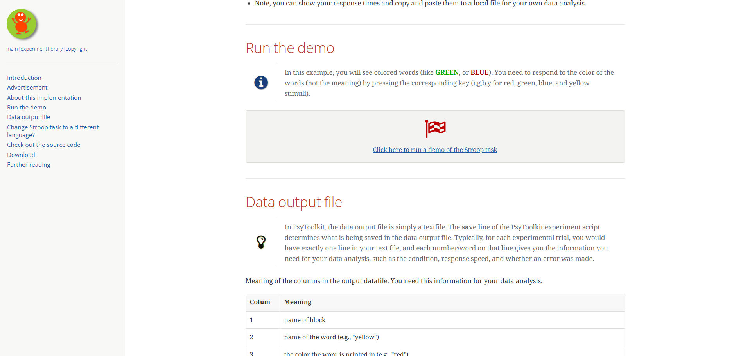
Figure 2.7 Homepage of PsyToolKit
The Stroop Test in PsyToolKit is available for single test and showing the result at the end of every test. Even though the user interface of the website is not so friendly, the website gives an easy access to everyone who wants to experiment with the cognitive testing. The result can be generated on the website but cannot be stored inside the website.
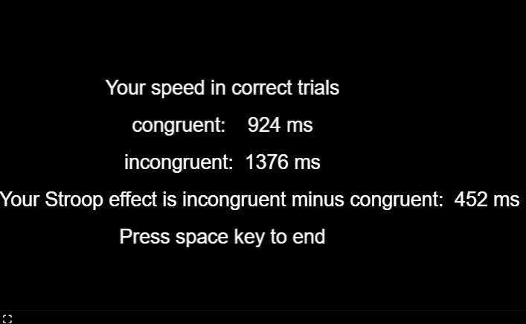
Figure 2.8 Stroop Test result in PsyToolKit
2.5.2 Milisecond
Milisecond is a website that provides MIST using Inquisit framework. MIST in Millisecond provides data analysis, response reaction, task completion. The system provides control over time and task consistency which help inducing controlled stresses in computer research. This system makes it suitable for research work.
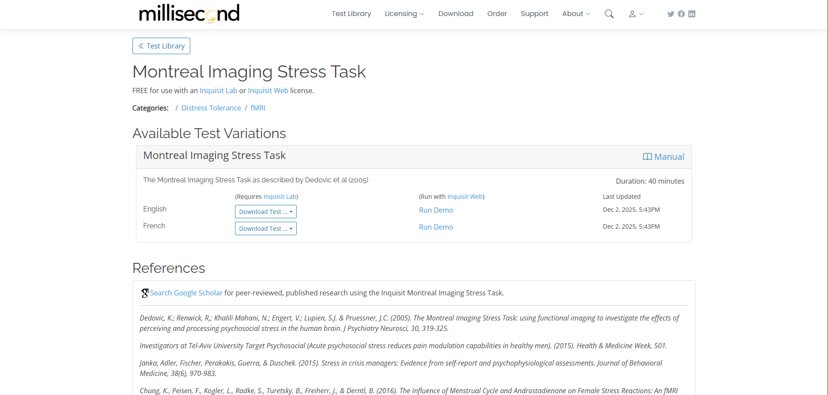
Figure 2.9 MIST in Millisecond.com
However, some requirements should be noted regarding the usage of the platform. These include the consideration that to utilize the platform, users are required to set up the Inquisit software on their computers prior to conducting any experiment. This setup may seem like an added burden compared to using fully browser-delivered models. Nonetheless, this platform can still be applicable in stress induction tasks.
2.5.3 Focusaur
Focusaur is another Stroop Test related website where can complete the Stroop Test within 60 seconds. Different from PsyToolKit, Focusaur are focus more into gamified and making user interesting on completing it. After completing the task, Focusaur will show the Quality Score and Response Speed in graph which help to analyse the level of stress based on score and speed.
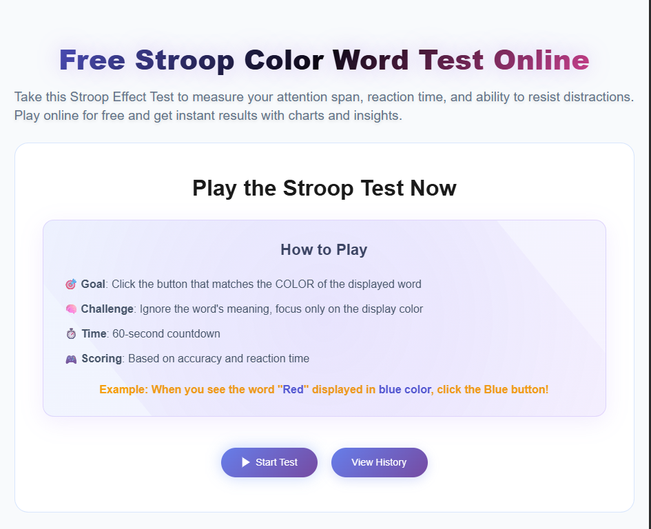
Figure 2.10 Homepage of Stroop Test in Focusaur.com
Even though the website is more polish, the website does not include the reaction recording device.
2.6 Methodology
The methodology for this project shows the process used for design and development for this project. Methodology shows the theoretical analysis and system procedures needed to ensure that the development is consistent in every phase (Al-Qudah, 2021). In system development a step of requirements analysis, design, implementation, and evaluation is required to produce the good product and focus on solving the user problem (Pressman & Maxim, 2020).
2.6.1 Agile
Agile software development is focus on flexibility, incremental progress and continuous feedback. Rather than building the whole system at once, Agile will breaks the development into different process known as sprints. Every sprint involves planning, design, develop, testing, deploy and review. This way, team can regularly assess and improve the product through responses from stakeholder.
Agile encourages teamwork, transparency, with the involvement of stakeholders during development. The continuous engagement help developer the evolving requirements and adapt quickly (Pressman et al., 2020). Agile allows fast prototyping and working functions are provided sooner for early testing and validation (Sommerville, 2016).
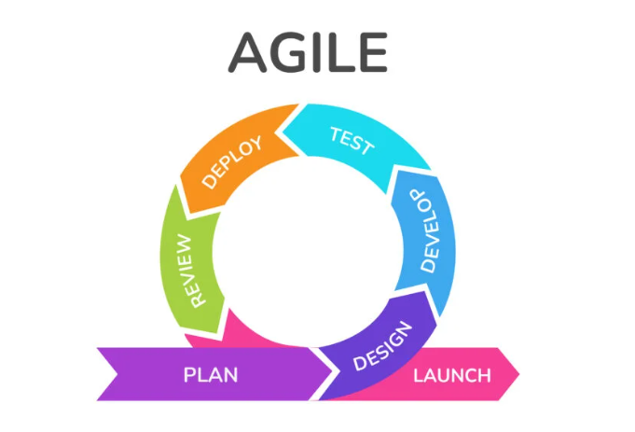
Figure 2.11 Agile Development Process (Amoros, 2025)
a) Planning Phase
In the planning phase, the project requirements are assessed and then prioritized according to the project needs. The tasks that require completion during the sprint and their timelines are also defined. This process will ensure that the development team is on the same page and knows exactly what they have to deliver during the upcoming sprint.
b) Design Phase
In the design phase, both the system architecture and the layout of the interface are described. There is development of user interaction, data flow, and system architecture to an extent that facilitates development. Agile Design is all about flexibility and simplicity, as it is easy to implement changes at the last stage.
c) Develop Phase
The development phase entails the implementation of the proposed functionalities through coding. The functional parts of the system are developed piece by piece, enabling developers to work with individual functionalities rather than the whole system. This promotes swift movement and offering functioning functionalities.
d) Testing Phase
In the testing stage, implemented functionalities are checked to find out bugs and functionality-related bugs and issues. Testing takes place at all stages within every sprint while developing software to make sure that new functionalities are properly implemented and do not hamper existing functionalities.
e) Deploy Phase
The deployment phase is the implementation of the tested functionalities in the working environment. In Agile, the deployment of the functionalities can happen frequently so that the stakeholders can test the newly developed functionalities of the system.
f) Review Phase
During the evaluation phase, the completed sprint is assessed by the team and the stakeholders. Feedback is collected for the system functionality, usability, and performance. Based on the feedback, the requirements undergo refinement to improve in the next sprint.
g) Launch Phase
This is referred to as the launch phase because this is where a functioning system is released for use. Though Agile promotes Continuous Releases, this is a milestone where the system has fulfilled its intended purpose and is ready for deployment.
2.6.2 Waterfall
The Waterfall model is one of the earliest and most traditional software development methodologies, known for a rigid step by step flow. This model moves through phases such as requirements, design, development, testing, deployment, and maintenance where each phase must complete before starting another (Pressman et al., 2020). This makes Waterfall highly structured because it clearly documented and defined in every phases.
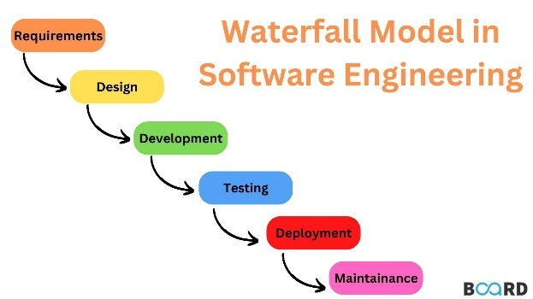
Figure 2.12 Waterfall Model in Software Engineering (Board Infinity, n.d)
Waterfall model works best when project needs are stable and clearly understood during development. The documentation helps ensure clarity which give the team understanding toward the requirements especially when stakeholders need formal approval before making progress (Pressman et al., 2020). However, this method can lead to cost increases and can be difficult to implement since it less flexible (Sommerville, 2016).
a) Requirements Phase
A technical requirement creates to analyse potential need, timeframes, and project parameter. The project is defined and planned at this stage but no process are mentioned yet.
b) Design Phase
A design specification document is created to outline the technical specifications for the design, including the programming language, hardware, data sources, architecture, and services.
c) Development Phase
The source code is developed using the models, logic, and requirements stated in the previous stages. Before the system is put together, it is usually coded in smaller parts or units.
d) Testing Phase
At this point, quality assurance, unit, system, and beta testing are used to identify issues that need to be fixed. The debugging stage of the development process may need to be repeated. The waterfall method continues if the system is developed and tested successfully.
e) Deployment Phase
Once the product or application has been proven to be completely functional, it is released into a live environment.
g) Maintenance Phase
Corrective, adaptive, and corrective maintenance can be implemented to continuously update, enhance, and improve the produced product as well as its operation. This can involve issuing new versions as well as patch updates.

2.6.3 Scrum
Scrum is an agile process that adopts the use of cycles to allow rapid and continuous improvement and adaptability during the planning process. Rather than depending on the use of structures, Scrum embraces the concept of collaboration, short cycles, and the ability to adapt to change when the need arises. Activities are conducted through specific time intervals called sprints, which range between one to four weeks, and during this time, a small and diverse team develops an incremental and usable piece of the work (Schwaber & Sutherland, 2020).
In Scrum, there are three roles in a Scrum team: Product Owner, who is in charge of prioritizing items in the product backlog. Then there’s the Scrum Master, who leads discussions while at the same time requiring that they adhere to rules of Scrum. And finally, there’s the Development Team, which takes care of actual work related to tasks. Events such as sprint planning, daily scrums, sprint review, or reflection are useful in all these. In addition to quickly identifying issues, along with continuous improvement (Schwaber, 2013).
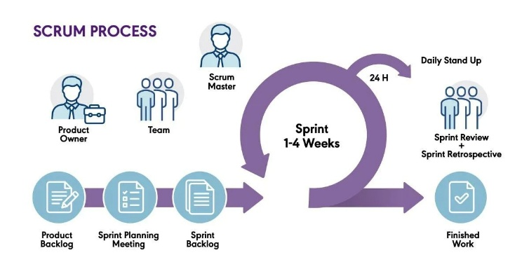
Figure 2.13 Scrum Process (Pm-Partners, 2024)
a) Initiation Phase
This phase is the critical steps in Scrum methodology. Initiation phase is the starting point of the project where the team will show the project vision including the roadmap, objectives, and goals. This phase will show all stakeholders and assign team to each role.
b) Planning & Estimates Phase
During this phase, the Scrum team does sprint planning where team identify which story to work during sprint. Sprint boards are used either physically or using software.
c) Implementation Phase
Implementation phase is the phase to execute the task and accomplish the goals to complete the project.
d) Review & Retrospective Phase
After every sprint, this phase will be an essential part to evaluate what was successful, what can be improved, and gathering the user feedback.
e) Release Phase
Release phase is the final phase of Scrum to publish the final project and turning them to the relevant stakeholders.
2.6.4 Comparison of the Methodology
Different approaches to building software offer distinct benefits based on what the project demands, how complex it is, or how much adaptability is needed. The table below summarizes the main differences among Agile, Waterfall, and Scrum.
Table 2.2 Comparison between Agile, Waterfall, and Scrum
Criteria | Waterfall | Agile | Scrum
Development Approach | Linear and sequential | Iterative and incremental | Iterative with structured sprints
Flexibility | Low – changes are difficult once phases are completed | High – requirements can evolve | High – adapts changes every sprint
Documentation Level | Heavy documentation before development | Moderate; documentation evolves | Light to moderate, focused on sprint goals
Delivery of Output | Final product delivered at end | Frequent small releases | Increment delivered every sprint (1–4 weeks)
Best Use Cases | Stable, well-defined requirements | Projects requiring adaptability | Fast-changing, experimental, and research-based systems
Source: Adapted from Sommerville (2016); Pressman & Maxim (2020); Schwaber & Sutherland (2020)
The Waterfall approach is selected for system development methodology, given the characteristics of the project. The nature of defined system requirements, project characteristics, and scope of development necessitate a structured and sequential approach to ensure that the development process is properly guided. This methodology maintains sharp divisions between phases, emphasizing comprehensive documentation and a step-by-step approach to requirements analysis, system design, implementation, testing, and evaluation. This structured process has made the Waterfall model effective in developing systems that have clearly defined objectives with fixed timeframes, especially in an academic system development context (Pressman & Maxim, 2020; Sommerville, 2016).
---> discussion 2.7
2.7 Summary
This chapter introduced literature on psychological stress, stress induction techniques, web-based systems, previous works, as well as system development methodologies with the aim of providing background work for the proposed work. The mechanisms, efficiency, as well as performance criteria, of leading stress induction techniques like Trier Social Stress Test (TSST), Montreal Imaging Stress Task (MIST), as well as Stroop Test, were introduced. To minimize human errors as well as increase data accuracy, there is the importance of automated recording as presented in this chapter. On the other hand, the characteristics of web-based systems, their architecture, as well as advantages, in addition to how applicable these are in stress induction on a centralized basis, were introduced. Although software development methodologies can be compared to support the selection of the development methodology suited for the system development, the existing platforms are introduced to explore what has been done by other researchers.

